This is a .doc file

This is a heading 1

This is a heading 2

This is a heading 3

This is a heading 4

This is a heading 5

This is a PNG:
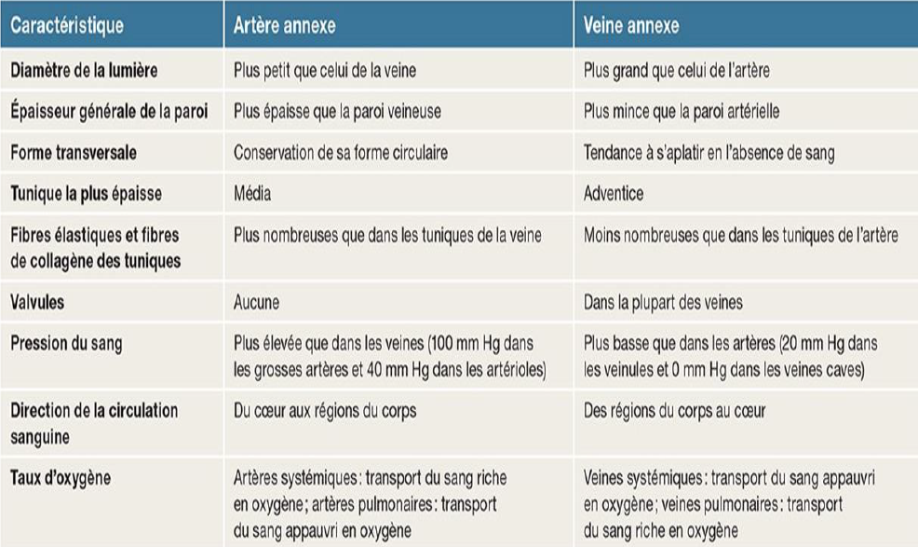

This text is underlined
This text is bold
This text is in italic
This text is in orange

This is a list:
- Item 1
- Item 2
- Item 3
- Item 4
- Item 5
This is another image (should be an .emf file):

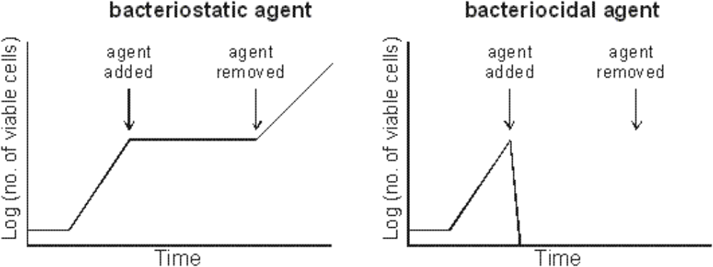

This is a table :
1 | 2 | 3 | 4 | 5 | 6
a | a | a | a | a | a
b | b | b | b | b | b
c | c | c | c | c | c
d | d | d | d | d | d
e | e | e | e | e | e

